

PIPELINE ROW PATROL INSPECTION REPORT

**Targa Resources (HGS)**  
Mont Belvieu and Highlands Areas

June 27, 2025

**CONFIDENTIAL DOCUMENTS**

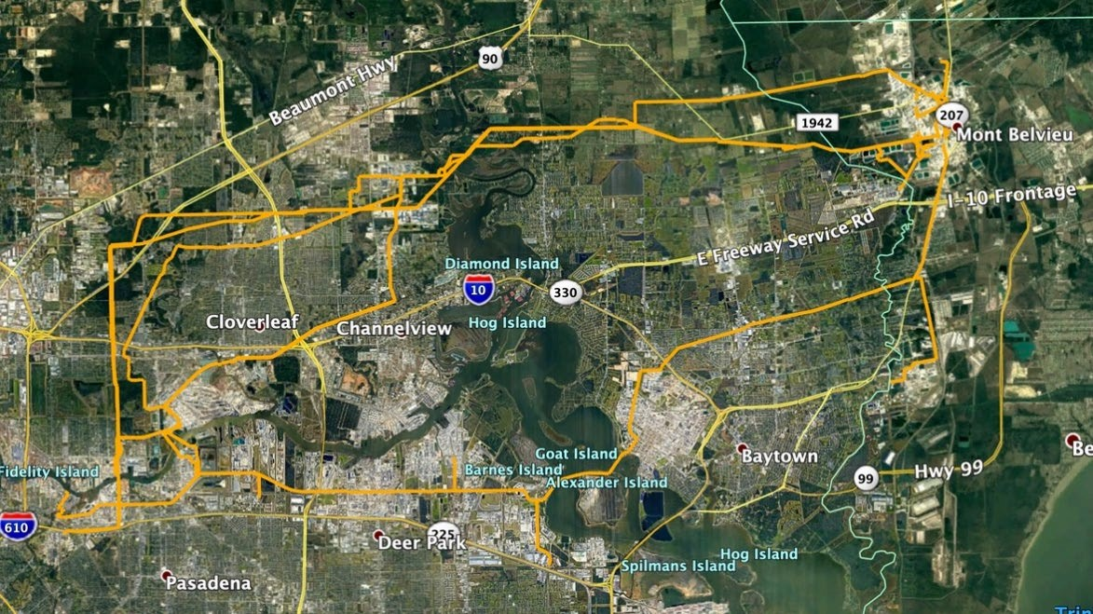

Arch Aerial, LLC

3801 Yale Street

Houston, TX 77018

281.974.5752